**Visual Inspection and Deep Learning**

*Group 56*

**Members**

Samuel Hearn

Jennifer Olenchak

Marco Peric

Robin Perlman

Ayden Rebhan

Brandon Spangler

**Team Sponsor**

Joseph Rivera, Lockheed Martin

[joseph.rivera@lmco.com](mailto:joseph.rivera@lmco.com)

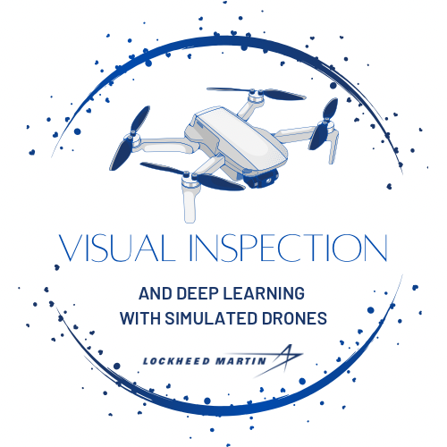

**Table of Contents**

Project Description 3

Broader Impact 3

Goals and Objectives 4

Project Motivations 4

Samuel Hearn 5

Jennifer Olenchak 6

Marco Peric 7

Robin Perlman 8

Ayden Rebhan 10

Brandon Spangler 11

Legal, Ethical, and Privacy Issues 12

Financing/Budget 12

Requirements 12

Tools and Libraries Required: 13

Project Ideas 13

Samuel Hearn 13

Brandon Spangler 13

Robin Perlman 14

Product Deliverables 15

Senior Design 1 15

Senior Design 2 15

Project Components 15

Team Structure and Component Division 16

Meeting Structure 16

Diagrams 17

SD1 Milestones 18

SD2 Milestones 18

# Project Description

Unmanned aerial vehicles (UAV), which are also commonly known as drones, are aircrafts which do not require a human pilot. These systems can either be remotely controlled by a human operator, but increasingly, there have been movements to have these drones fly themselves. Using machine learning, many researchers and companies have sought to have complete automation of drone flying. The problem with using machine learning to teach a drone though is it can be difficult to obtain training data. To solve this problem, Microsoft AirSim was developed to provide a simulated environment for obtaining training data to train a model to successfully control a drone. This effectively mitigates the problem of obtaining training data and now that leaves researchers with the ability to train their models to control drones.

This project aims to use Microsoft AirSim to develop an Object Detection Algorithm to identify objects of interest in an environment and then run subsequent Convolutional Neural Networks to classify and further extract pertinent features about the selected objects. This can prove to be especially useful for detecting vehicles with a drone and finally logging important statistics as well as information about the vehicles. In partnership with Lockheed Martin, this project will be able to provide viable solutions to strengthen the capabilities of drones in conjunction with Machine Learning. These findings can lead to a significant impact for future endeavors of Lockheed Martin and could also broadly impact the field of drone autonomy.

# Broader Impact

The focus of this project aims to use drones for visual inspection. This development is being done for Lockheed Martin. If this project is successful the technology developed could be adapted to survey weapon internals, active environments, or find specific targets. Therefore, as a team we need to be aware of the potential defense implications that our technology could be used for. Even with this being the case, there is a very real case that our technology could have lasting impact in a commercial setting.

This project could also be used to inspect critical infostructure and save lives. It also allows for areas to be surveyed quickly without the need for direct human contact. A user could fly a drone through a dangerous area and inspect for broken vehicles, 5G cell towers, crashed planes, storm damages. All environments where it would be safer for drones to be sent in rather than a human. This would make the technology developed a necessary and have a significant impact on remote inspection.

# Goals and Objectives

The goals of the project include the following:

* To deliver a successfully trained model which can be used to detect objects in a simulated environment and perform further feature extraction.
* To learn modern Deep Learning Frameworks and utilize these technologies to train models
* To gain experience working in a group setting using Agile practices.
* To learn how to work alongside a sponsor to develop software which meets the needs of the stakeholders

The objectives of the project include the following:

* Create a training environment in Microsoft AirSim
* Develop a simple pathing algorithm for the simulated drone to fly
* Collect training data from the environment
* Train an object detection algorithm to detect notable objects in the environment
* Run further machine learning models on these areas of interest to extract features using Explainable AI

# Project Motivations

As a group, we are extremely interested in partaking in this project. Overall, we see this as a phenomenal learning opportunity that can help us in our careers. The ability to work in a team setting and provide results to a sponsor is a great way to learn about software development and we are excited to put our education to the test as we work on developing a model for deep learning on the Microsoft AirSim drone simulation. Of course, it is also important to state how beneficial it is to gain new networking connections both within the senior design group and within the sponsor! It is possible that some of us may end up working in similar fields or roles, and it is very important to have connections to bring along.

Additionally, this opportunity provides us with experience in walking through the software development lifecycle (SDLC) on a novel machine learning problem. While the SDLC for this project should not significantly differ from that of a “usual” software development (such as a full-stack application) project, some stages may require more attention or time, such as the testing or debugging phases, as artificial intelligence problems like underfitting or overfitting may take a lot of time to resolve.

## Samuel Hearn



Photo 1.1 Samuel Hearn

My motivation for this project is to take a step into an uncomfortable direction and acquire deep learning skills which I have always garnered interest in yet never had the chance to work in-depth with. It has always been an area of interest to me because I think artificial intelligence can be applied to many areas and such, I can always apply this new knowledge to other areas whether I choose to keep programming for visual inspection or other areas. I currently have minimal experience in real life projects which has always been a small fear of mine entering the job market. To alleviate this fear, I will make sure my time on this project is not wasted.

The end goal for me is to eventually develop games after senior design, I want to see if the deep machine learning skills can be applied to such an area. Additionally, I want to learn more about the simulation software that is being used in this project as that uses Unreal which has a much clearer connection to my interest in game development. Unreal is a tool that is particularly useful and one I can imagine myself using in the future, so I want to gain a solid grasp on how to work within it during the duration of this project.

A Final addendum to my motivations, I hope that I find what it is I want to do after graduating with this project. I said I wanted to follow the route of game design, but if there is something I enjoy more about deep learning I could entirely reconsider what field I want to work in; or at the very least realize I do not have to program in one specific area to have a satisfied work experience and happy life. The work I do on this project will not only help me with my intrinsic motivations but also extrinsic, as this project will hopefully give me better job offers.

## Jennifer Olenchak



Photo 1.2 Jennifer Olenchak

In working on this project, I am energized by the opportunity to understand the complexities behind deploying a deep learning model to address a novel problem in an innovative way. I first discovered my natural passion for artificial intelligence after taking an introductory AI course in my junior year at the University of Central Florida; In this course, I was able to gain an understanding of the basic concepts in AI, fundamentals of machine learning, and deep learning through formal course instruction and the completion of several small-scale projects. In looking to further evolve my understanding and knowledge set, I completed an 8-hour NVIDIA Fundamentals of Deep Learning training workshop and was introduced to an expanded array of python libraries, such as Keras and TensorFlow, to complete projects relating to convolutional neural networks, transfer learning, and natural language processing.

My attention for this project was especially captured when I learned that it was being sponsored by Lockheed Martin. Through the UCF College Work Experience Program (CWEP), I have been working as a part-time Software Engineer CWEP in a student contractor role for Lockheed Martin since April 2021. This past summer, I took a break from this position to work as a Software Engineer Intern at Lockheed Martin, returning to my CWEP role upon its completion in the beginning of the Fall semester. Over the course of my Lockheed Martin internship, I was selected to participate in the first inaugural Artificial Intelligence Intern Pathways Program. In this program, I received the opportunity to further my knowledge of the artificial intelligence field in relation to the business prospects of Lockheed Martin specifically, as well as collaborate with fellow interns to design a CNN image classification model API, which we won second place for. At the conclusion of my internship, I was extended an offer to return to Lockheed Martin as a Software Engineer Associate when I graduate in May 2023. In participating in this project, I am thrilled to be able to further contribute to the technical advancements of the corporation I will be starting my career with and continue to expand my network of professional connections.

## Marco Peric

Photo 1.3 Marco Peric

My motivation for this project is to try to gain further experience with machine learning, and I also would like to try to learn what it is like to work on a team trying to solve a machine learning problem. Furthermore, my love for AI and computer vision was another reason I was so excited to work on this project.

Most recently, I created a computer vision model, using PyTorch, that could play the browser game *Geoguessr* at an above-average level. To train the model, I wrote a Python script for a web scraper that collected Google Maps imagery (about 250k images upon completion) and used the Resnet-52 architecture for the computer vision model. After training the model on an RTX 3070-TI for 50 hours (fine-tuning, as retraining Resnet would have yielded marginally improved results), a test accuracy of 62% was achieved, which meant that, more often than not, my AI could correctly guess the country a particular Google Maps image was taken in!

I would also like to make connections with my group members and with Lockheed Martin so that I can work as a machine learning engineer early in my career. I would like to work on creating models and working with the MLOps for these models. I think that as a prospective machine learning engineer, it is important to familiarize myself with MLOps and understand how to deploy instances for the storage and computation aspects of a ML project.

Personally, I am familiar with Google Cloud and Amazon AWS for these purposes, having utilized their free trials, but I would also like to gain more familiarity with Docker and Kubernetes and other containerized deployment schemes, as they are extremely commonly used for speeding up deployment.

## Robin Perlman

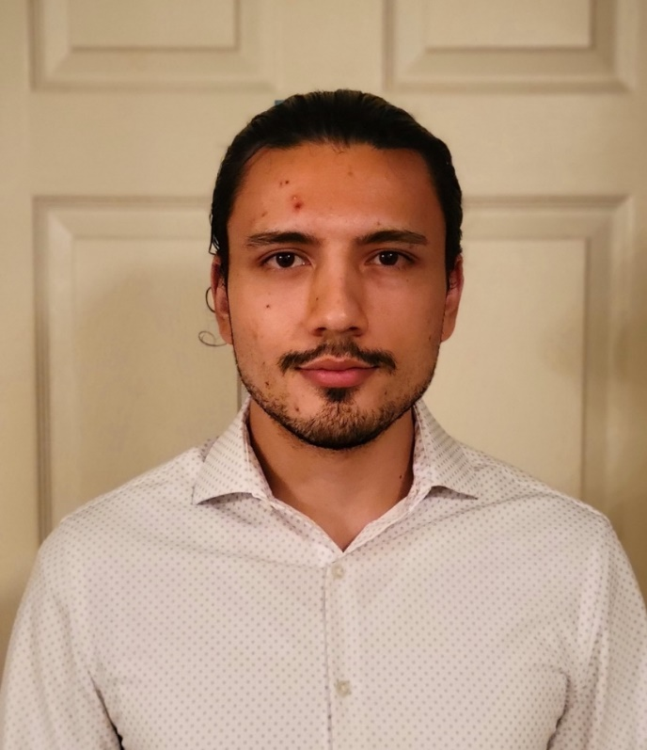

Photo 1.4 Robin Perlman

My motivation for choosing this project is my interest in working on Machine Learning. I have taken many courses related to AI (Artificial Intelligence) and Machine Learning and I am hoping to gain more real-world experience with these topics. When I learned about this project, I was immediately intrigued because I felt that this would be the perfect way to bring my education into practice.

This project will allow me to become more familiar with Object Detection Algorithms as well as develop Convolutional Neural Networks to perform feature extraction and classification. I also am excited to work with Microsoft AirSim because it gives me the opportunity to learn about modern technology that could improve current methods of training Drones. Currently, it is extremely hard and impractical to gather real data for training drones. Using simulations to train models seems to be an interesting method to solve the problem of having accessible training data. Because we will not be limited by the amount of data available, I am confident that we will be able to train an impressive model.

Another reason for my motivation to work on this project is to potentially present our findings to real engineers at Lockheed Martin. This project could pave the way for major innovations, and I am excited to be able to have the opportunity to work with Lockheed Martin and meet extremely intelligent individuals who could provide us with feedback and long-term guidance, not just for this project, but for our careers.

Overall, I think this project will be an amazing opportunity to solidify and strengthen my knowledge by working with talented individuals on a project that could provide an impact for the future of drone training as well as learn to work with a reputable company to deliver results. This project provides me with many chances to demonstrate a growth mindset and hone my skills as a developer.

## Ayden Rebhan

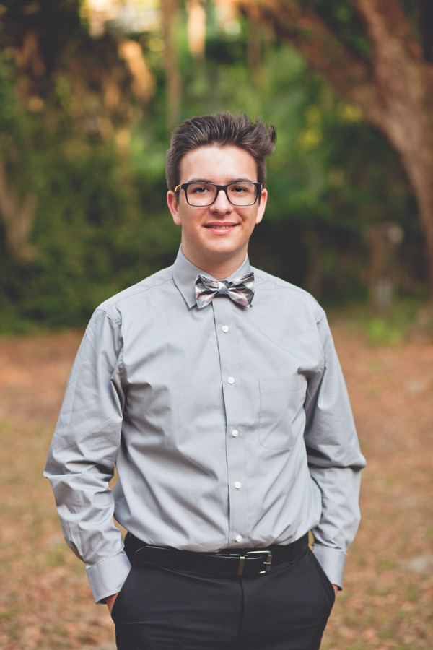

Photo 1.5 Ayden Rebhan

My main motivation for choosing this project was to learn more about a topic I have had much interest in, but not much experience. I have always been interested in artificial intelligence and deep learning since I was in high school, but never really got too much hands-on experience with it. This project seems like a perfect opportunity for me to learn about artificial intelligence and get a good feel for what working on a team is like. I have worked on a team before in an internship and in my processes for object-oriented software development class in the spring and I am looking forward to adding this project to my list of experiences. I am especially looking forward to expanding my skills as a developer and taking this project head on.

I am especially motivated to take part in the whole project design process, I have never taken a project to the point of showcase, and I am especially excited to take part in the process. On top of that, working alongside an amazing company like Lockheed has always been a goal of mine and I am very motivated to make sure I make a good impression on our sponsor. Another motivation of mine is learning how to use all the software tools we are using in this project. Many of them are used in the real world, such as Unreal Engine and Microsoft AirSim, and having proficiency in them will look great on my resume.

Another motivation of mine, granted its assumed, is graduating! This class will be a part of my last act as a college student, and I would like to make the most out of it. I am hoping that this project will be the perfect “cherry on top” for my whole college career.

## Brandon Spangler



Photo 1.6 Brandon Spangler

My main motivation for choosing this project is to learn more about deep learning. I have taken a few courses at UCF (University of Central Florida) about AI (Artificial Intelligence) and Machine Learning, and by the time we get to deep learning it always feels very rushed. I want to get the full experience and really understand what is going on in the network and what pathways are causing the network to make its predictions. When having the drone inspect different objects, I want to be able to see how changing what we input to the model affects the predictions or how adding more layers affects the model’s performance.

In addition to learning more about Deep Learning and how networks are deployed, this project will also be a great chance for me to learn about some recent technologies. I will be working the Unreal Engine and Microsoft AirSim. These are two areas I have not touched on in my academic career thus far. Getting the simulation environment working and using a 3D creation tool will be a great experience and another reason I personally chose this project.

Finally, I am also motivated to see a project be deployed. All the other projects at UCF have not been on the kind of scale here and I want to understand the development process. I want to see how we go from some basic code, developing the neural networks, and deploying the project to Microsoft AirSim and getting it out there to show other people. I want to create something that I can be proud of and want to talk about with my family and friends.

# Legal, Ethical, and Privacy Issues

There should be no legal issues with this project considering we are working under Lockheed Martin, a government security company. While this project is done under their supervision and guidance there are no legal issues perceivable.

In the field of machine learning especially intended for drones there could be ethical issues if the subject of inspection was something living like humans or even animals, and how that would be used for future drone projects, but as the subject of our inspection should be only vehicles the ethical issue is much diminished or even removed.

It could be argued that there are privacy issues with the act of inspecting people's belongings like their cars, yet some concerns may be quelled by the fact that this project is done in the name of a government security company. If we are inspecting cars, license plates are tied to every person, and it is always legally required to be shown so that you can be identified. Making a drone inspect a car should not be an invasion of privacy because everything the drone inspects is an outward appearance and therefore public to all who see it.

# Financing/Budget

The budget for this project is $300. These funds will be used to pay for assets to use when developing our simulation environment. Other ways these funds will be used are to provide necessary training to group members to brush up on Deep Learning and Object Detection. If necessary, part of the budget will also be set aside to investigate cloud hosting options for running simulations for training.

# Requirements

The following is a list of requirements for the Visual Inspection and Deep Learning Project:

* Develop a testing environment using Microsoft AirSim
  + Successfully run the Microsoft AirSim and build the appropriate solutions to run the simulations
  + Design the test environment by using existing assets
  + Successfully capture environmental information from the Drone
* Use the AirSim API to connect to the simulation with Python
  + Successfully control the Drone using API
  + Implement simple path following algorithm for Drone to navigate environment
* Train a YOLOv5 Object Detection algorithm to identify vehicles
* Develop Convolutional Neural Networks to extract features to learn more about identified vehicles
  + Train the network to accurately identify features.
  + Modify hyperparameters accordingly to increase accuracy.
* Display the results of the drone to a user

# Tools and Libraries Required:

* Unreal Engine v4.27
* Microsoft AirSim
* PyTorch
* OpenCV
* Deep Learning
* Convolutional Neural Networks
* Object Detection Algorithms (YOLOv5)

# Project Ideas

## Samuel Hearn

1. Be able to create a distribution map of where objects were inspected
2. Make a user-friendly UI for seeing results of algorithms
3. Anomaly Detection, Unreal allowing. Tires and windshields breakage etc.
4. Being able to identify and name precise models of vehicles
5. See if modifications have been made to the vehicle.

## Brandon Spangler

1. Allow for multiple objects to be detected simultaneously
2. Remote real time monitoring of drone
3. Using an RNN (Recurrent Neural Network) for enhanced drone movement
4. Have 2 or more drones perform the same inspection for better results
5. Ability to collect environment data while inspecting to be later used for improved algorithm training

## Robin Perlman

1. Account for weather conditions when training the model
2. Use an API to parse a string from an image (parsing license plate information)
3. Use an object detection algorithm to specify areas of interest for running further Machine Learning Models

Jennifer Olenchak

1. Implement a top-down map view of clickable nodes to view collected and derived vehicle data in the user GUI.
2. Represent the position of detected objects using both their exact location in the environment and their relative position to one another.
3. Train, test, and validate the model using simulated data that reflects a variety of combinations in environmental conditions (Ex: daytime rain, nighttime rain, etc.).

Ayden Rebhan

1. Implement a learning algorithm able to identify what kind of vehicle it is. (Truck, SUV, sedan, coupe, motorcycle, etc...)
2. Implement an algorithm designed to identify and label higher traffic zones and be able to map out the most efficient route given a start point and end point based off that data.
3. Experiment with a function that allows the drone to be able to identify objects that do not belong on the road, such as fallen trees, trash, broken tires, etc.

Marco Peric

1. Experiment with a camera array and use picture stitching to create 360-degree images
2. Consider using an ensemble learning approach, using multiple models to extract multiple features and produce weighted results
3. Consider using OCR (optical character recognition) for reading text-based information from imagery
4. Consider using GANs to create new data or to enhance low-quality data
5. Create useful and informational analytics that highlight the data collection, training, or runtime processes

# Product Deliverables

## Senior Design 1

* A final draft of the design document.
* A Functional Prototype
  + Simulation environment up and running
  + Baseline algorithms
  + Overview of all the algorithms that will be used

## Senior Design 2

* Fully functional version of the simulation and model
* Refine, train, and improve the accuracy of algorithms applied by the model.
* Final Design Document
* Proof-of-concept recorded simulation demonstration
* The link to a robust, well-documented, easily cloneable GitHub repository

# Project Components

* Explainable AI
  + Explainable artificial intelligence enables individuals to easily understand conclusions made by AI models and algorithms to take away the mystery of model decisions.
  + Rather than construct a model that forms a single high-level conclusion, our model will detect individual features and components to provide multiple aspects of data conclusions to perform visual inspection in a variety of contexts.
  + Display the collected data on a navigable GUI.
* Visual inspection deep learning model
  + Layer various models and models form a visual inspection algorithm.
  + Initial proposition of a model architecture:
    - The base model will likely be YoloV4 for object detection. It provides bounding boxes for each class that the model was trained for. This will allow for the nomination of select target areas to focus additional CNN model layers onto.
    - Analysis of the gradients from the YoloV4 weights
  + Counting problem
    - Collect data on the environment in relation to the cars
      * How many cars are parked on a given street?
      * Map cars’ relational position to one another
    - Collect data on individual cars
      * Make and model
      * Paint color
      * Number of wheels
      * License plate reading
      * Any text or phone numbers present on the vehicle
* Simulated virtual environment
  + Allows for the collection of data, training of model, and practical application of the model.
  + A variety of lighting and weather conditions can be simulated to stress and improve model performance in complex and realistic environments.
* Simulated Drones
  + Use a prefab quadcopter model to begin, which contains several baseline features to avoid starting from scratch.
  + Add virtual components, such as cameras and sensors, to simulated drones to provide data to implement into AI model.
    - Multiple types of data points
  + Segmentation maps of the environment will be captured to detect the pixels that are related to objects to be detected, eliminating a need for lengthy manual labeling process.
  + Establish a flight path methodology
    - A. Straight-line flight path to follow streets, as supported by AI model
    - B. Virtual joystick to control drone flight

# Team Structure and Component Division

1. Simulation Environment
   1. Jennifer Olenchak - Project Manager, Simulation Environment Lead
   2. Samuel Hearn
   3. Brandon Spangler
2. Neural Network and Object Detection
   1. Robin Perlman - Neural Network and Object Detection Lead
   2. Marco Peric
   3. Ayden Rebhan

# Meeting Structure

* Biweekly Status report Meeting with Joseph Rivera
* Weekly Sync with Team
* Agile Daily Remote Standups

# Diagrams

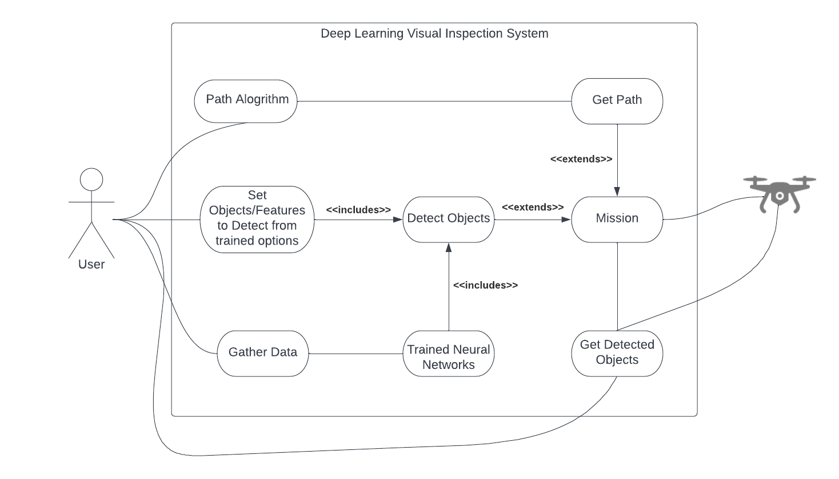

Figure 1.1 Use Case Diagram of System

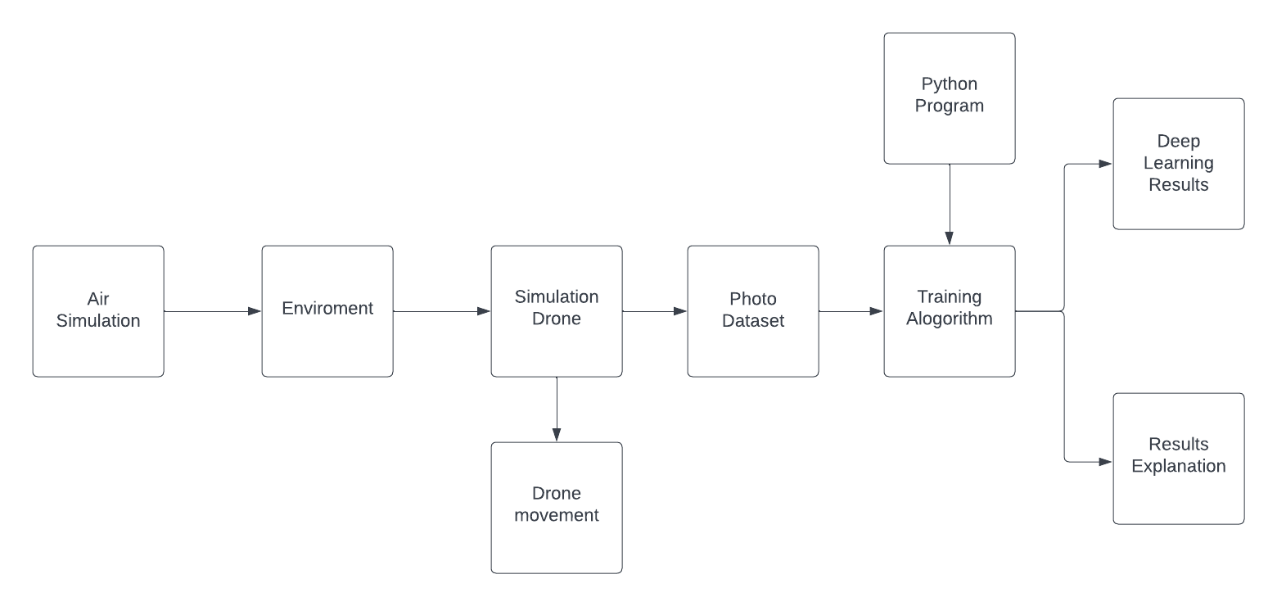

Figure 2.2 Block Diagram of System

# SD1 Milestones

|  |  |
| --- | --- |
| Date | Milestone |
| 9/14/22 | Team Formation |
| 9/18/22 | First Meeting |
| 10/5/22 | TA Check-in #1 |
| 10/7/22 | Finalize Assignment 3 Documentation |
| 10/7/22 | Successfully Run Microsoft AirSim (Have basic block environment running for all members) |
| 10/14/22 | Connect to AirSim environment via Python API |
| 10/19/22 | Gerber Check-in #1 |
| 10/21/22 | Finish Literature Survey |
| 10/21/22 | Finalize Selection for Object Detection Algorithm (YOLOv5, etc.)  Determine changes needed to be made to AirSim environment to enhance training |
| 10/28/22 | Begin obtaining training data for drone  Begin developing object detection model and convolutional neural network |
| 11/11/22 | Finish obtaining training data  Start training model |
| 11/27/22 | Prepare Prototype, Simulation Environment, NN model demonstration  Present solution proposal to Lockheed Engineers |
| 12/4/22 | Final SD1 Deliverable: Meeting with team of engineers at Lockheed with Joe |

# SD2 Milestones

|  |  |
| --- | --- |
| Date | Milestone |
| 1/13/23 | Construct a presentation feedback write-up and assess next steps |
| 1/27/23 | Perform modifications to Convolutional Neural Network to increase accuracy and address feedback |
| 2/3/23 | Run changes to CNN on the AirSim |
| 2/17/23 | Further refine Network and Object Detection  Write documentation related to key findings and modifications |
| 3/3/23 | Have Finished Version of Project Prepared |
| 3/17/23 | Prepare Demonstration for Dr. Gerber |
| 3/31/23 | Demonstration for Dr. Gerber |
| 4/14/23 | Update Documentation and speak with Sponsor for overall feedback |
| 4/28/23 | Final Presentation – week before finals start at UCF |
| 5/3/23 | Finalize GitHub Repo, Update pertinent documents |